**(This pdf contains -Business and Marketing understanding ,BRD , PRD , User Journey and workflow )**

# Business and Market understanding

## Project Name: Neighborhood Delivery Optimization

## Name : Nikhita Narendra Watpal

## Document Version: 1.0

## Date: 22/02/2024

Table of contents

|  |  |  |
| --- | --- | --- |
|  | Introduction | 3 |
|  | Key Partners of Swiggy | 3 |
|  | Objectives | 3 |
|  | Industry Overview | 4 |
|  | Target Audience | 4 |
|  | Market positioning | 5 |
|  | Business model | 5 |
|  | Marketing and sales strategy | 6 |

1. Introduction:

Swiggy is one of the most popular online food delivery startups in India which has established its roots and managed to reach more than 500 Indian cities. Throughout its journey, Swiggy collaborated with many restaurants across India and provided delivery boys with huge opportunities to earn more pennies by providing their valuable delivery service to customers’ demands.

* 1. Key Partners of Swiggy:

Swiggy has partnered with many food merchants to provide the platform users the best food ordering and delivery. There are many partners with whom Swiggy has collaborated successfully, and some of its key partners, then they are:

* Restaurants and retail shops who are considering registering themselves with the platform.
* Delivery providers provide their valuable delivery service to foodies on their demand.
* Part-time or full-time freelancers who provide their service to earn some extra penny.
  1. Objectives:
* Develop strong relationships with retail stores and restaurants.
* Hire full-time and part-time delivery providers.
* Provide easy and quick payment gateways to provide an excellent experience to customers.
* Manage and monitor the delivery process to ensure excellent delivery service to foodies.
* Develop and manage tech infrastructure and keep it updated.
* Handle customers’ and partners’ problems effectively.
* Manage customers in order to acquire them.

1. Industry Overview:

The food delivery and e-commerce industry have experienced significant growth, driven by changing consumer preferences and the increasing adoption of online services. As the market evolves, players in the food delivery sector, including Swiggy, are exploring innovative solutions and technologies to stay competitive. Market research indicates a continued upward trajectory, with a focus on convenience and quick service.

Established with a mission to revolutionize food delivery, Swiggy has evolved into a major player in the industry. Since its inception, Swiggy has expanded its service portfolio, offering a comprehensive range of features through its user-friendly app. The company's growth trajectory has been marked by strategic partnerships and a commitment to providing a seamless dining experience for its users.

1. Target Audience:

Swiggy caters to a diverse user base, including individuals of various age groups and preferences. By employing sophisticated segmentation strategies, Swiggy tailors its services to meet the distinct needs of different customer segments. Understanding the demographics and behaviors of its users allows Swiggy to enhance the overall customer experience.

Swiggy's target audience is diverse, encompassing individuals with varying preferences, lifestyles, and dining needs. The platform caters to a broad spectrum of customers, recognizing that the modern consumer values convenience, variety, and quick service. The primary focus is on urban and semi-urban areas, where the demand for food delivery services is high.

Swiggy's services are tailored to meet the needs of users in specific geographic locations. The platform strategically expands its operations to urban centers and areas with a high concentration of potential users.

These strategies involve personalized recommendations based on order history, targeted promotions aligned with user preferences, and the introduction of features that cater to specific demographics.

1. Market positioning:

Swiggy's brand image plays a crucial role in its market positioning. By consistently delivering on its promises and offering a superior user experience, Swiggy has established itself as a trusted and reliable food delivery service. Monitoring market share and continually refining its strategies enables Swiggy to maintain a favorable position. Swiggy's market positioning is a strategic effort to establish a distinctive and favorable perception among its target audience within the highly competitive food delivery sector.

Swiggy has diligently built a strong brand image centered around reliability and trustworthiness. The brand is associated with timely and accurate deliveries, quality service, and a wide variety of restaurant choices. The customer-centric approach is evident in personalized promotions, discounts, and tailored recommendations.

1. Business Model:

The business model of Swiggy is based on a hyper-local on-demand food delivery business model. It makes use of modern technology and techniques to satisfy the growing demand for foodies in the market. It acts as a bridge between eaters and restaurants. It operates successfully on a dual partnership model, which proved to be more beneficial for retail stores and restaurants if they opt to perform their food service through the platform.

Swiggy's revenue streams are diverse, encompassing delivery fees, restaurant partnerships, and promotional activities. A thorough understanding of its cost structure allows Swiggy to optimize operations and maintain a sustainable business model. This strategic balance between revenue generation and cost management contributes to the company's financial success.

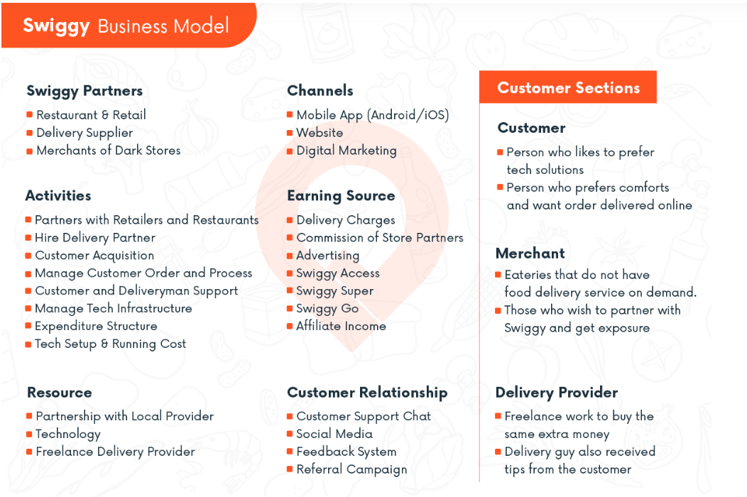

1. Marketing and sales strategy:

* Targeted Marketing Campaigns: Swiggy designs and executes targeted marketing campaigns to reach specific customer segments. These campaigns leverage data analytics to identify trends, preferences, and demographics, allowing Swiggy to tailor promotions that resonate with different user groups. From exclusive discounts for new users to personalized promotions based on order history, the strategy aims to attract and retain a diverse customer base.
* Strategic Partnerships: Collaborating with restaurants and other culinary establishments is a key aspect of Swiggy's sales strategy. By forging strong partnerships, Swiggy ensures a wide array of cuisine options for users, enhancing the platform's appeal. Exclusive partnerships and promotional tie-ups contribute to Swiggy's competitive edge, attracting both users and businesses.
* Data-Driven Decision Making: Data analytics plays a pivotal role in Swiggy's market and sales strategy. By analyzing user data, order history, and market trends, Swiggy gains valuable insights into customer preferences and behaviors. This data-driven approach enables the platform to make informed decisions regarding promotions, partnerships, and overall business strategies.
* Social Media Presence: Maintaining an active and engaging presence on social media platforms is an integral part of Swiggy's marketing strategy. Regular updates, interactive content, and responding to user queries on social media platforms help build brand awareness, strengthen the Swiggy community, and encourage user participation.

# Business Requirements Document (BRD)

## Project Name: Neighborhood Delivery Optimization

## Document Version: 1.0

## Date: 22/02/2024

### Document History

|  |  |  |  |
| --- | --- | --- | --- |
| Version | Date | Author | Description |
| 1.0 | 22/02/2024 | Nikhita Narendra Watpal | The initial draft of the BRD |

### 

### Table of Contents

**Business Requirements Document (BRD) 7**

Document History 7

Table of Contents 8

1. Introduction 9

1.1 Purpose of the Document 9

1.2 Scope of the Project 9

1.3 Document Overview 9

2. Business Objectives 10

2.1 Business Goals 10

2.2 Project Objectives 10

2.3 Success Criteria 10

3. Current Business Environment 11

3.1 Current Processes 11

3.2 Challenges and Issues 11

4. Proposed Solution 12

4.1 Description of the Solution 12

4.2 Functional Requirements 12

4.3 Non-Functional Requirements 12

5. Constraints 13

5.1 Budgetary Constraints 13

5.2 Timeline Constraints 13

5.3 Regulatory Constraints 13

6. Assumptions 14

6.1 List of Assumptions 14

7. Risks 15

7.1 List of Risks 15

7.2 Risk Mitigation Strategies 15

8. Dependencies 16

8.1 List of Dependencies 16

9. Approval 17

### 1. Introduction

#### 1.1 Purpose of the Document

The purpose of this project is to streamline the delivery process by assigning a common delivery person to customers located in the same neighborhood, ensuring faster and more efficient service.

#### 1.2 Scope of the Project

The scope of this project extends to the implementation of a geographically optimized delivery system within our food delivery app. This system will identify and group customers in the same area, allowing for consolidated deliveries and minimizing wait times.

#### 1.3 Document Overview

This document serves as a comprehensive guide to the project. It includes detailed insights into the industry landscape, a thorough explanation of the proposed functionality, its benefits, and a strategic approach to implementation.

### 2. Business Objectives

#### 2.1 Business Goals

This project aims to achieve several key business goals such as to enhance overall customer satisfaction by minimizing delivery times and providing a more efficient and reliable food delivery service and Operational efficiency by focusing on optimizing delivery operations by grouping orders in the same geographic area.

#### 2.2 Project Objectives

The primary business objectives of this project involves seamless integration of the new functionality which is developing and implementing the feature to identify and group orders in the same neighborhood, optimizing delivery logistics for greater efficiency, enhanced customer communication and a reliable discount mechanism.

#### 2.3 Success Criteria

The project aims to achieve a reduction in average delivery times, indicating improved operational efficiency and customer service. Increased customer retention rates post-implementation will be a crucial success criterion.

### 3. Current Business Environment

#### 3.1 Current Processes

The current business processes of our food delivery platform involve receiving customer orders through the mobile app or website, assigning delivery personnel based on proximity, and ensuring timely delivery to the specified locations.

#### 3.2 Challenges and Issues

The current business environment faces several challenges that justify the need for the project. Firstly, the traditional model of dispatching individual orders to the nearest available delivery person may result in inefficient use of resources and increased delivery times. The absence of a systematic approach to group orders in the same locality poses a challenge to optimizing delivery logistics.

### 4. Proposed Solution

#### 4.1 Description of the Solution

The proposed solution, introduces a novel functionality to our food delivery app with a focus on optimizing delivery operations and enhancing customer satisfaction. This project leverages geospatial technology to identify customers in the same neighborhood and strategically assigns a common delivery person for their orders.

#### 4.2 Functional Requirements

1. Geospatial Identification
2. Order Consolidation
3. Real-time Tracking
4. Discount Mechanism
5. Integration with Existing Systems

#### 4.3 Non-Functional Requirements

[List the non-functional requirements, such as performance, security, scalability, serviceability, maintainability and usability, that the solution must meet.]

### 5. Constraints

#### 5.1 Budgetary Constraints

This project must operate within specified budget constraints, limiting the financial resources available for development, implementation, and ongoing maintenance. This may include considerations for software development, testing, marketing, and any additional costs associated with infrastructure upgrades.

#### 5.2 Timeline Constraints

The project operates under specific timeline constraints, with predefined deadlines for different phases such as development, testing, and deployment. Time is of the essence, and delays may result in missed opportunities or increased competition. Meeting these timelines is crucial to align with market demands and maintain a competitive edge.

#### 5.3 Regulatory Constraints

This project must navigate various regulatory and compliance requirements related to the food delivery industry. This includes adherence to food safety standards, data protection regulations, and any local or national laws governing the operation of online delivery platforms.

### 6. Assumptions

#### 6.1 List of Assumptions

1. Users have access to a stable internet connection for seamless app usage.
2. The existing technology infrastructure can accommodate the implementation of the project without significant upgrades.
3. Delivery personnel are adequately trained and equipped to handle grouped orders efficiently.
4. Customers will perceive delayed deliveries as occasional and not a frequent occurrence.
5. The discount mechanism for delayed orders will positively impact customer satisfaction and loyalty.

### 7. Risks

#### 7.1 List of Risks

The project faces several potential risks, including technical challenges in implementing the new functionality, unexpected issues arising from the integration with existing systems, and the possibility of user resistance to the changes.

#### 7.2 Risk Mitigation Strategies

To mitigate technical challenges, the project team will conduct thorough testing and engage in continuous communication with the development team. Integration risks will be addressed through a phased implementation approach, allowing for incremental adjustments and minimizing disruptions.

### 8. Dependencies

#### 8.1 List of Dependencies

The success of this project is dependent on the seamless integration with other ongoing projects within the organization. Compatibility and synchronization with related initiatives are critical to ensure a cohesive user experience and overall system functionality.

This project relies heavily on the availability and expertise of key resources, including skilled developers, project managers, and support staff.

External factors, such as third-party collaborations, regulatory compliance, and market conditions, significantly influence the project. Successful partnerships with restaurants and other stakeholders are crucial for the functionality's effectiveness.

### 9. Approval

We, the undersigned stakeholders, have reviewed and approved the content and objectives outlined in this project document. By signing below, we acknowledge our agreement with the proposed goals, objectives, constraints, and strategies presented in this document.

Stakeholder 1: _________________________ Date: _______________

Stakeholder 2: _________________________ Date: _______________

Project Approved on: ________________

# **Product Requirements Document (PRD)**

## Project Name: Neighborhood Delivery Optimization

## Document Version: 1.0

## Date: 22/02/2024

## Table of Contents

|  |  |  |
| --- | --- | --- |
|  | Introduction | 20 |
|  | Definition and objectives | 21 |
|  | Definition table | 22 |
|  | Objectives | 23 |
|  | Features list and priority | 24 |
|  | Future work | 25 |

## 1. Introduction

*Name : Nikhita Narendra Watpal*

*College : Marathwada Mitra Mandal’s College of Engineering Pune*

*Year : BE IT*

|  |
| --- |
| Swiggy is a leading food delivery app renowned for its seamless and efficient service. Connecting users with a diverse range of restaurants, it offers quick and reliable delivery, real-time order tracking, and a user-friendly interface. Swiggy has become synonymous with convenient and delightful dining experiences, making it a preferred choice for those seeking hassle-free food delivery. |

## 2. Definition and Objectives

The project aims to enhance our food delivery app by introducing a geographically optimized functionality. The project leverages geospatial technology to identify and group customers in the same neighbourhood, assigning a common delivery person for their orders.

Project Objectives:

1. Optimize Delivery Operations: Implement a system that strategically groups orders in the same geographic area with the user’s choice minimizing travel distances for delivery personnel and optimizing overall delivery operations.
2. Enhance Customer Satisfaction: Improve the customer experience by offering more efficient and quicker deliveries, and implementing a discount mechanism for orders experiencing delays, demonstrating a commitment to customer satisfaction.
3. Competitive Advantage: Position our food delivery app as a leader in the industry by introducing a unique and innovative feature that sets us apart from competitors, contributing to increased market share and user loyalty.
4. Operational Efficiency: Streamline delivery processes, reduce operational costs, and ensure a smooth integration of the project functionality with our existing technology infrastructure, enhancing overall operational efficiency.

### 2.1 Definition Table

Use this table to define the what, why, who, and how of your product idea.

|  |  |
| --- | --- |
| **What** is the problem? | The problem lies in the inefficiencies of the current food delivery system, where orders are dispatched individually without considering the geographic proximity of customers and customer’s consent if they are willing to go for group delivery |
| **Who** is experiencing it? | Users face longer wait times for their orders, resulting in a less satisfactory experience whereas delivery personnel navigate suboptimal routes, affecting their efficiency and potentially leading to delays. User will have option for group delivery . |
| **How** will you solve it? | The proposed solution utilizes geospatial technology to identify customers in the same neighbourhood and strategically assigns a common delivery person for their orders if the order gets placed in 15 mins |
| **Why** is your solution better? | This project offers a systematic approach to neighbourhood-based delivery, providing a more efficient and quicker service with consent and in 15 mins By consolidating orders in the same area, it minimizes travel times for delivery personnel, resulting in cost savings and reduced environmental impact. |

### **2.2** Objectives

|  |  |
| --- | --- |
| **Vision** | The vision of this project is that users should experience swift and efficient deliveries, delivery personnel operate on streamlined routes, and our platform provides solutions within the food delivery industry. |
| **Goals** | Optimize delivery operations by strategically grouping orders in the same neighbourhood, Elevate the customer experience by providing quicker and more reliable deliveries, and provide a discount mechanism for delays. |
| **Ideal Customer Persona** | The ideal customer persona for this project is a tech-savvy urban or semi-urban individual, often busy, seeking quick, and reliable food delivery services like Swiggy or Zomato. |

## 3. Feature list and Priority

|  |  |  |
| --- | --- | --- |
|  | **Feature name** | Geospatial Identification |
|  | **Priority of the feature** | High |
| **Description of the feature** | Utilizes geospatial technology to identify users in the same neighborhood, enabling the grouping of orders in a specific geographical area. |
| **Goal the user wants to reach** | Minimize travel distances for delivery, optimizing delivery routes. |
| **Problem it solves for the user** | Reduces delivery times, enhancing overall operational efficiency. |
|  | **Feature name** | Order Consolidation |
|  | **Priority of the feature** | High |
| **Description of the feature** | Consolidates orders from customers within the same area, facilitating efficient delivery operations. |
| **Goal the user wants to reach** | Streamlined and consolidated deliveries for users in the same neighborhood. |
| **Problem it solves for the user** | Minimizes travel distances for delivery personnel, reducing operational costs. |
|  | **Feature name** | Discount Mechanism |
|  | **Priority of the feature** | Medium |
| **Description of the feature** | Implements a discount mechanism for orders experiencing delays, demonstrating a commitment to customer satisfaction. |
| **Goal the user wants to reach** | Compensation for users in case of delayed deliveries. |
| **Problem it solves for the user** | Addresses user dissatisfaction caused by occasional delays, fostering goodwill. |

## 

## Future Work

|  |  |
| --- | --- |
| **Feature name** | **Priority** |
| Multi-Language Support | Should have |
| In-App Chat Support | Must have |
| Advanced Search Filters | Should have |
| Dietary Preferences | Nice to have |
| Scheduled Deliveries | Must have |
| Loyalty Program | Nice to have |

User Work-Flow Diagram -

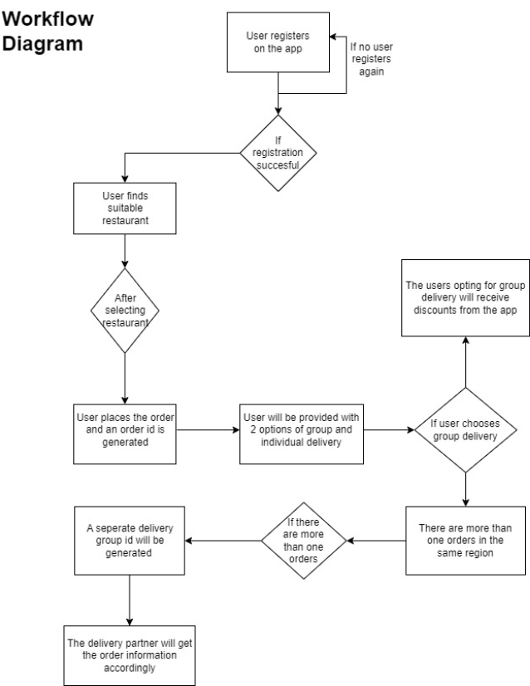

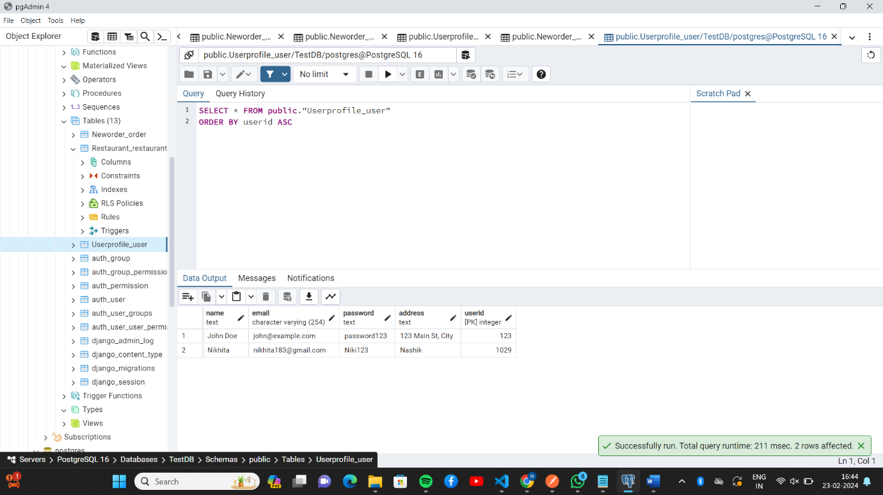

Fig 1 : User Profile database

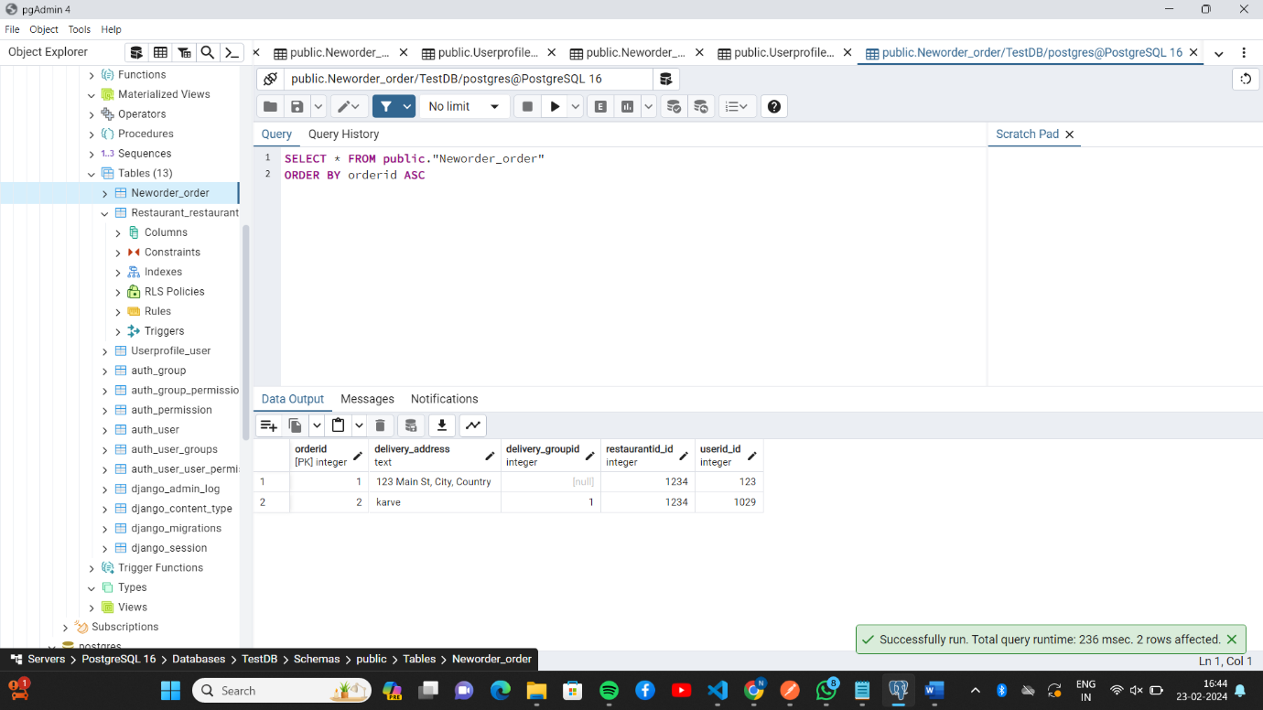

Fig 2 : New Order database

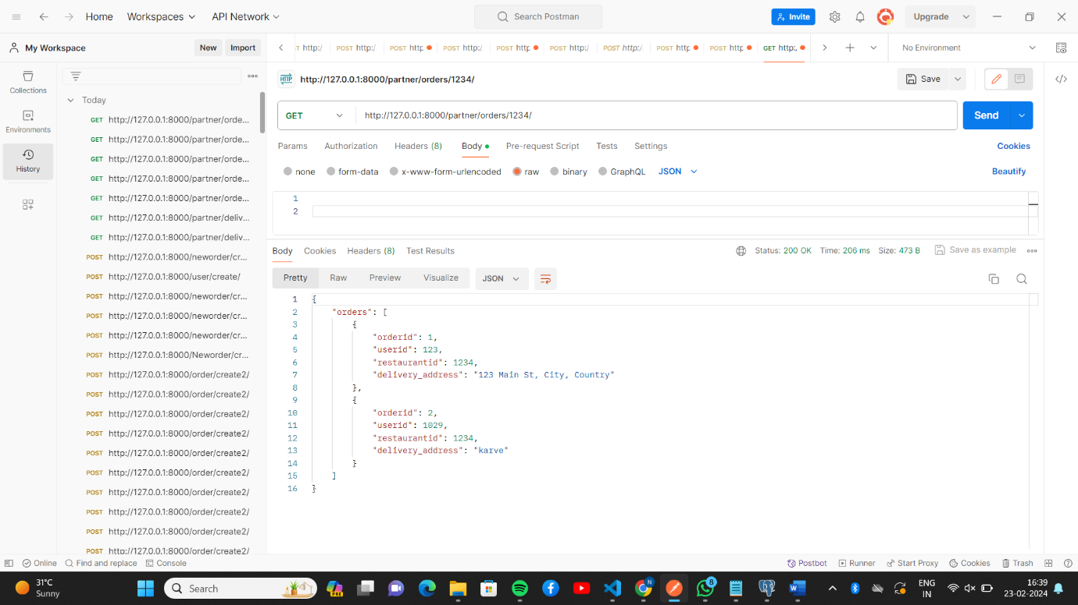

Fig 3 : Group Delivery

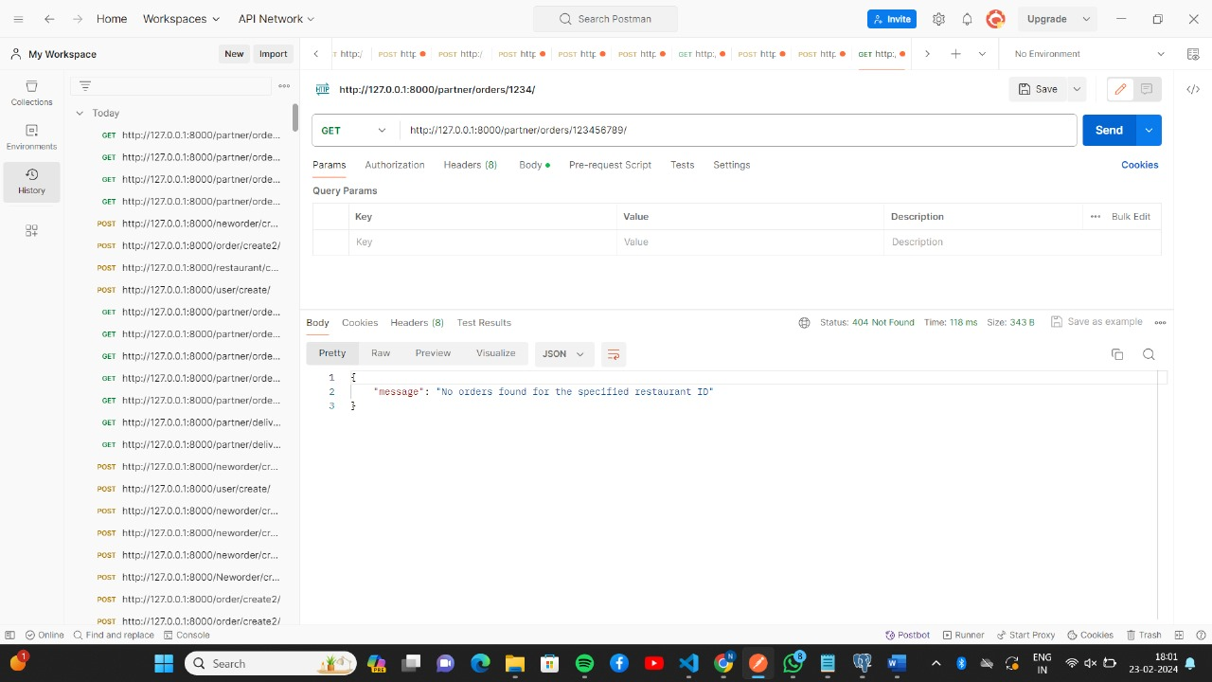

Fig 4: New order with different restaurant id